# heroku-docker-nginx-example

## Steps

<https://github.com/heroku/heroku-docker-nginx-example>

### Heroku Button

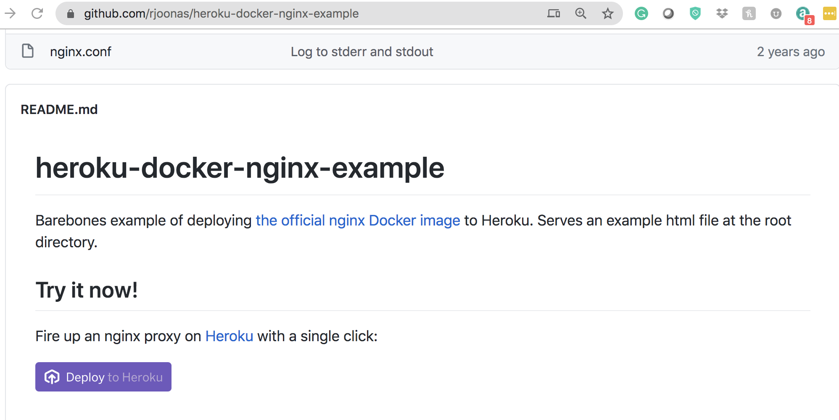

### Manual Steps

git clone https://github.com/rjoonas/heroku-docker-nginx-example.git

cd heroku-docker-nginx-example

heroku container:login

heroku create 'nfjs-nginx-docker'

heroku container:push web

heroku container:release web

heroku open